First Quarter

Honor Roll

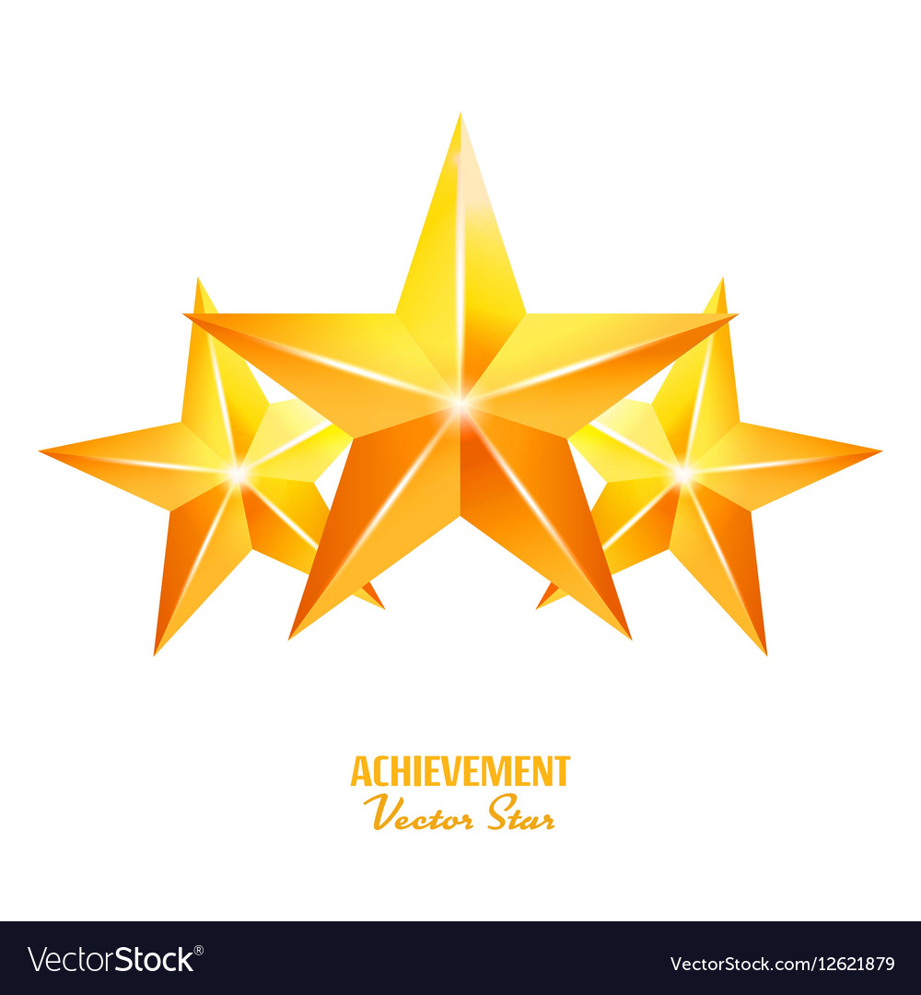7th Grade

Magarsa Abubaker Isis Ariana Andrade Vijil

Tina Biswa Miley Blanton

Landon Buxton Jonathan Castillo Ramirez

Fatoumata Conde P'yaire Cooper

Nyiraneza Florance Mireya Gaitan Soriano

Stephanie Garcia Leonardo Garcia Arreola

Citihna Ghimerey Eden Gurung

Haji Hassan Magali Hern

Edwin Hernandez-Vazquez Tramaize Hite

Kaedyn Hodge Saniah Hylton

Deion Johnson Mariah Jones

Aariel Jude Akta Kami

Mark Lemon David Loomis

First Quarter

Honor Roll

7th Grade Cont.

Kamrin Madison Kaley Maldonado Maldonado

Eliza Martin Nuurto Matan

Crispin Mendez Anjana Monger

Kamani Moore Edgar Morales Gomez

Erick Najera Bacilio Angel Navarrete Sierra

Tito Petito Braighlynn Purcell

Samjana Rai Budoor Raisan

Paco Ruiz-Robles Lyric Shavers

Bryce Steier Trey'Quan Underwood